

**PROTOCOL**to exercise

***Capacity coupling on flat Ribbon-Cables***

|  |  |  |
| --- | --- | --- |
| Class | Secretary | Signature |
| **4BHELS** | **HOFSTÄTTER A.** |  |
| Exercise- / Delivery date | Employee | Signature |
| 4th March 2015 |  |  |
| Teacher | Employee | Signature |
| GRASINGER |  |  |
| Grade | **Employee** | Signature |
|  |  |  |
| ***Capacity coupling on flat Ribbon-Cables*** | | |
| **Used Devices**   |  |  |  |  |  | | --- | --- | --- | --- | --- | | Nr. | Device | Manufacturer | Type |  | | 1. | **Oscilloscope** | **-** |  |  | | 2. | **Function generator** | **-** |  |  | | | |

Inhalt

2 Task 3

3 Measurement 2: Shielding of flat-band-cables 3

3.1 Measurement 3

3.2 Task A 3

3.2.1 100Hz 3

3.2.2 1kHz 4

3.3 Task B 4

3.3.1 100Hz 4

3.3.2 1kHz 5

3.4 Task C 5

3.4.1 100Hz 5

3.4.2 1kHz 6

# Task

A square signal generator had to be connected to a flat ribbon cable at its first and fourth line. An oscilloscope was connected to the other two lines in several ways. Some frequencies of the generator between 100Hz and 1kHz had to be set.

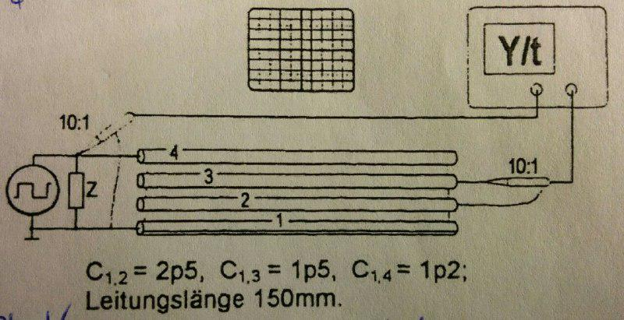

# Measurement 2: Shielding of flat-band-cables

## Measurement

Settings of the Generator: $f=10 kHz, U=5 V_{SS}$

## Task A

Measure the coupling voltage on the wires 2 (Ground) and 3 (probe).

Measured Value: $U2=690 mV$

Some pictures were taken to show how the signal on line 4 influences line 3. The yellow signal is the square of the generator and the green one is the signal which was measured on line 3.

### 100Hz

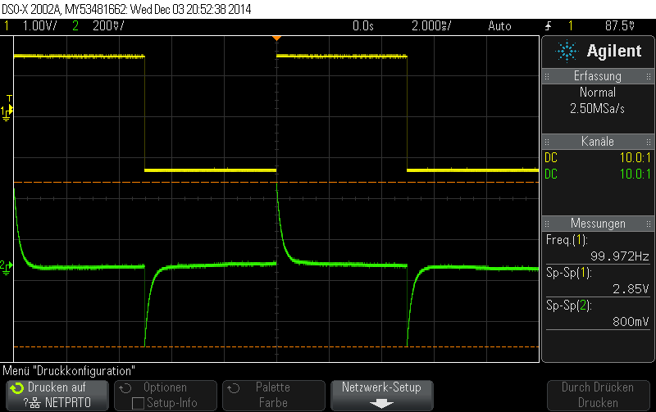

### 1kHz

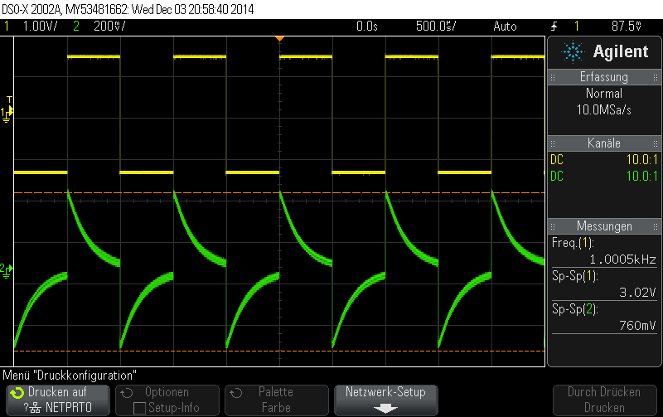

## Task B

The Oscilloscope was connected from line 2 to line 3

The green signal was measured on line 2. Between line 2 and 4 is line 3 so it can be seen that the influence is lower.

### 100Hz

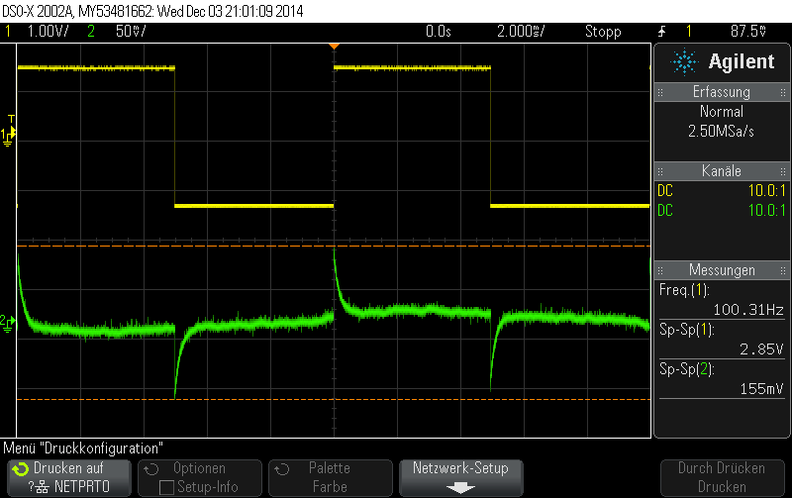

### 1kHz

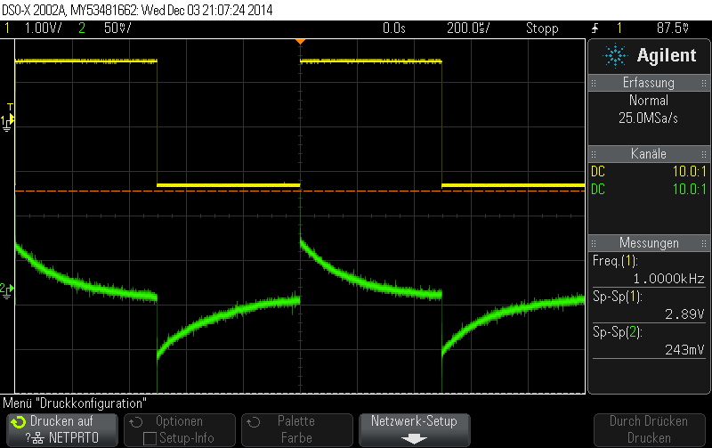

## Task C

The Oscilloscope was connected on line 2 without connecting ground.

Now the ground got disconnected and the results had to be shown.

### 100Hz

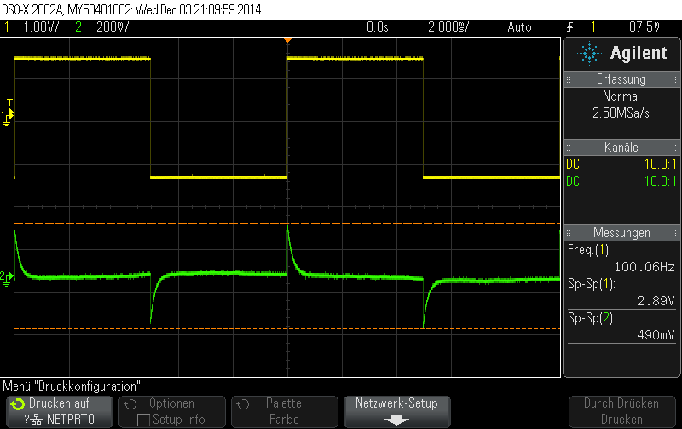

### 1kHz

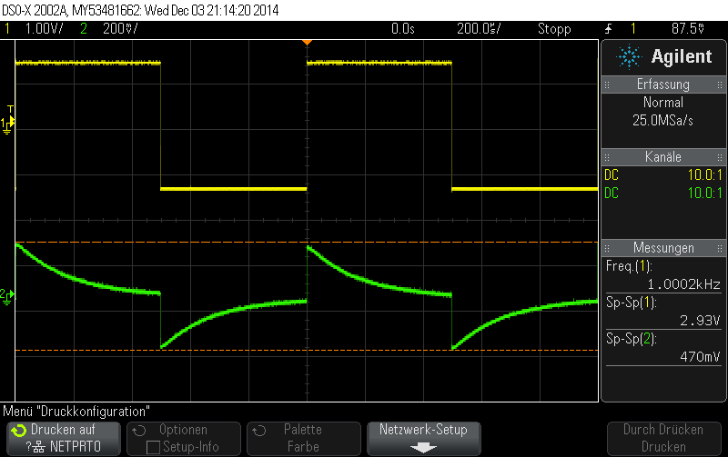

Result: At measurement two it can be seen, that if the frequency of the generator increases, the peak Voltage of the measured signal also increases. The voltage is lower than in task one because there is wire 3 which blocks a part of the influence.